|  |  |
| --- | --- |
|  |  |
|  | Bot Service  Build a Question and Answer Bot with QnA Maker |

Contents

Overview 3

Create a New Bot 4

QnA Maker for the Bot to create data file 11

Terms of Use 20

|  |
| --- |
| Overview |

### Summary

This lab explores how to create a QnA Bot with the Azure Portal and QnA Maker.

It will walk through the creation of a Bot with the Azure Portal and then to create questions and answers with QnA Maker.

### Business Case

Software bots are everywhere. You probably interact with them every day without realizing it. Bots, especially chat and messenger bots, are changing the way we interact with businesses, communities, and even each other. Thanks to light-speed advances in artificial intelligence (AI) and the ready availability of AI services, bots are not only becoming more advanced and personalized, but also more accessible to developers.

For this lab, you will be QnA Maker and then have the Bot Framework use the service to answer specific questions.

This is a small use case, and many more options are available, however this lab is to provide the process which a Bot can be created quickly using the Bot Framework in the Azure Portal and to interface with the QnA Maker.

### Learning Objectives

Upon completing this lab, you will have hands-on experience with the following functions and concepts related to the Bot Framework in the Azure Portal and the QnA Maker:

* Create a Bot in Azure Portal
* Create a QnA Knowledge Base
  + Enter in custom Questions
  + Enter in custom Answers
  + Save, retrain and Publish QnA Maker
* Intergrate QnA Maker with Bot
  + Copy and paste values from QnA Maket into Bot
  + Run the Bot

### Lab Requirements/Prerequisites

* A Microsoft Azure account is required to access the Portal and QnA Maker. Also will need a personal Live account.

<https://www.microsoft.com/en-us/account/default.aspx>

|  |
| --- |
| Create a New Bot |

### Create/Access an Azure Bot in the Azure Portal

To get started, you will need log in to an Azure Subscription. An Azure Subscription is like an all-inclusive development environment with the tools to create, manage, and publish Bot Services as well as a vast number of solutions based within Microsoft Azure.

1. Open Internet Explorer (or any other browser) using the shortcut on the desktop taskbar.
2. Go to the Azure Portal website by typing <http://portal.azure.com> in the address bar.
3. Enter the email address and password associated with your Microsoft ID, and click the Sign In button.

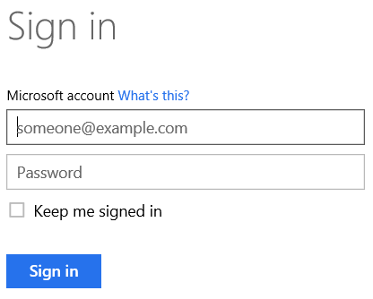

1. Upon logging in you should see the default view of the Azure Portal. 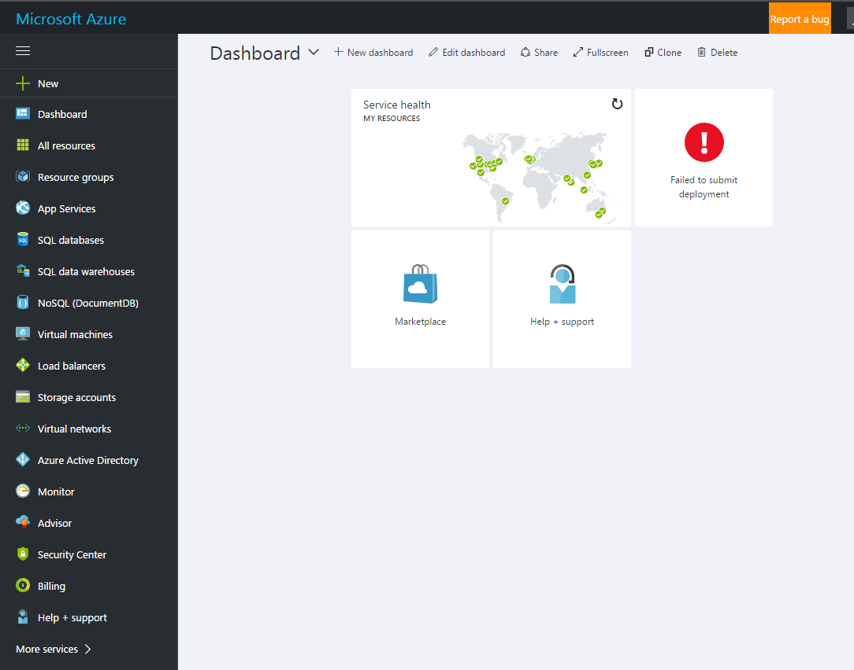

### Create a new Bot

Next, we will create our first Bot. A Bot is a collection of services which will be created for each person\team.

1. Click the NEW button in the top left corner of the page and enter Bot in the Filter field and finally Click the Create button.

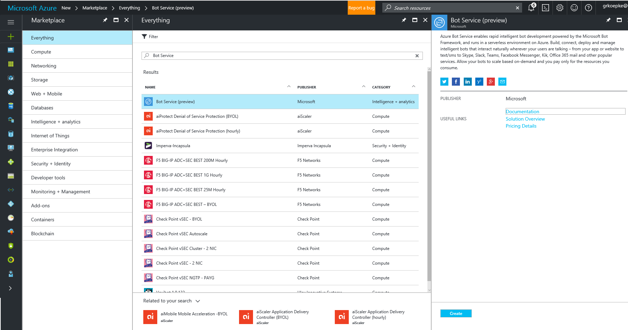

1. Enter in the App Name, pick the correct Subscription, Enter the Resource Group and finally Location.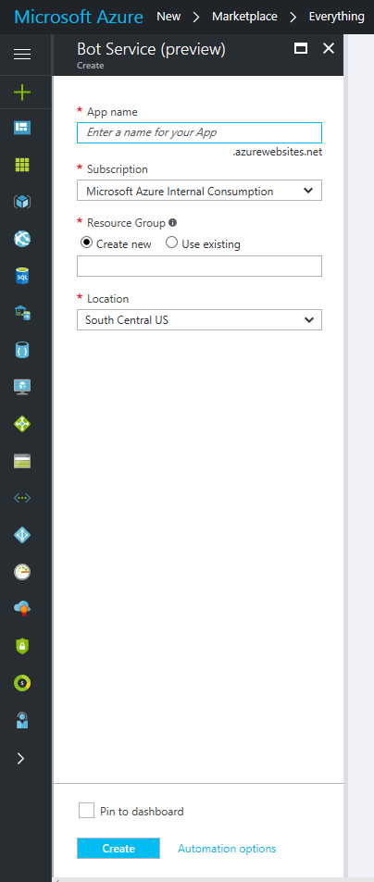
2. After the Create button is pushed you will then see a Deployment Started prompt and once the services are created will see a Deployments Succeeded Status.
3. Next navigate to Notifications and here you will see the status of the Deployment then click on the Deployment to see the Create a Microsoft App ID. Click the Create Microsoft App ID and password.

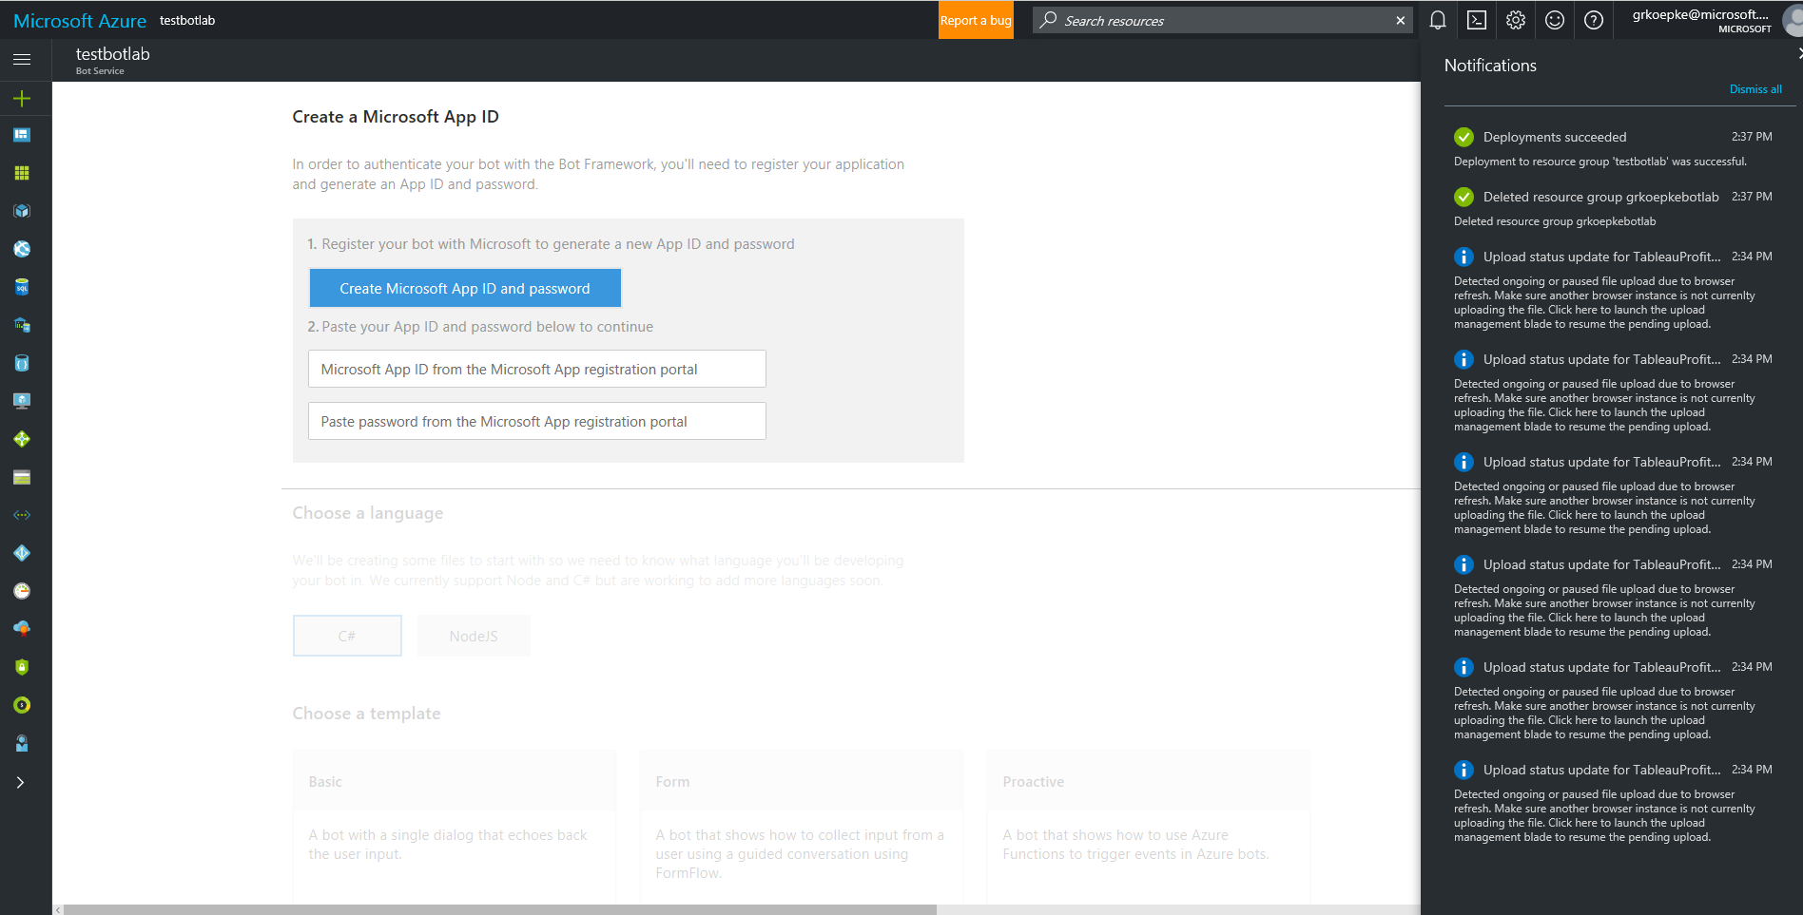

1. You will then be prompted to use your Personal Live ID to Generate the App ID and password.

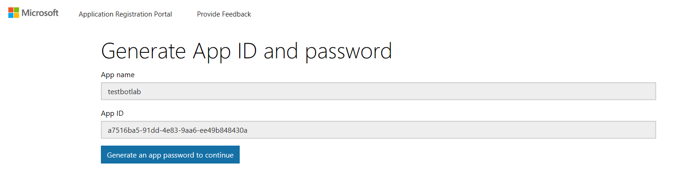

1. 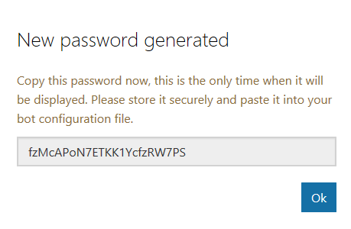Click the Generate an app password to continue button and copy the password into your clip board.
2. Now Paste your password into the Password field and you will then be prompted to choose your language and template for your Bot. For this Lab choose C# and Question and Answer then click Create Bot.

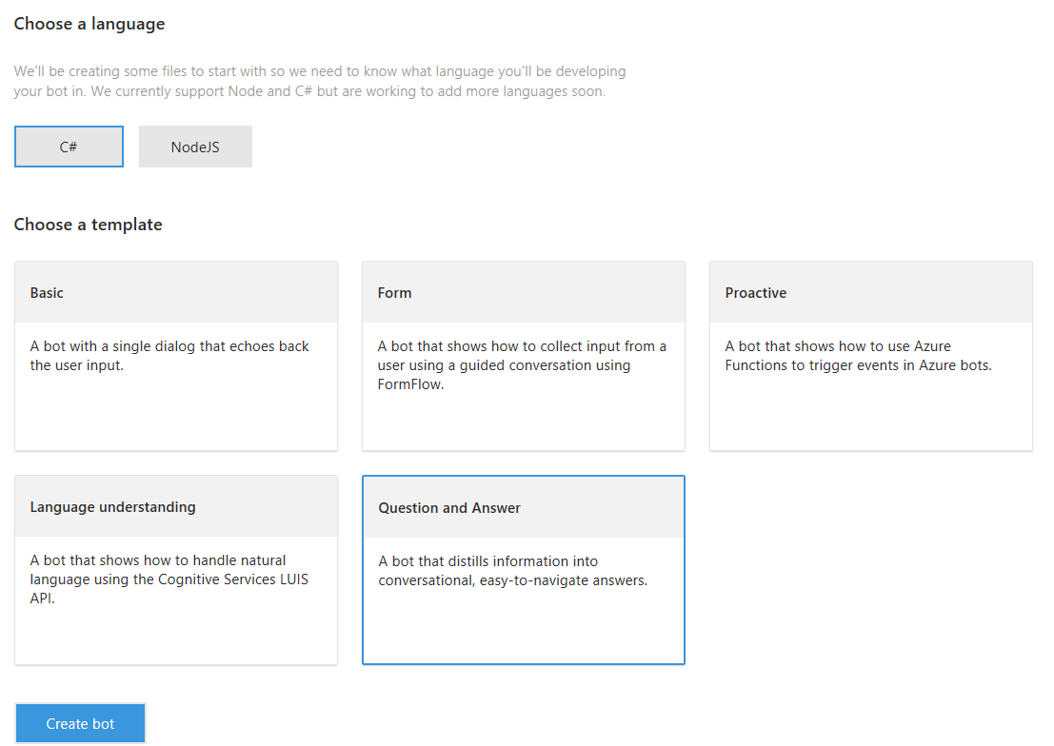

1. After clicking Create Bot you will be taken to the QnA Maker screen where you will Create a new knowledge base.
2. Next you will click on the Finish and go back to Bot Framework.

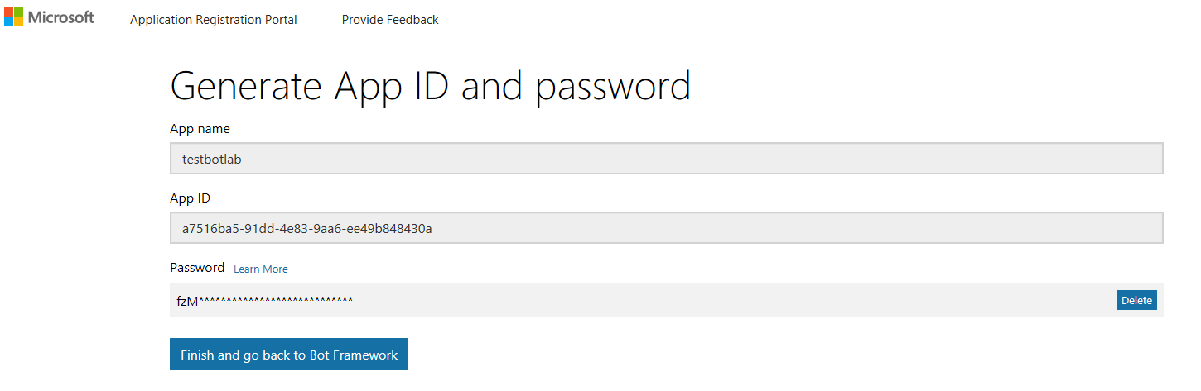

1. Here you will be then directed to the QnA Maker screen where you will Create a new knowledge base by Clicking OK.

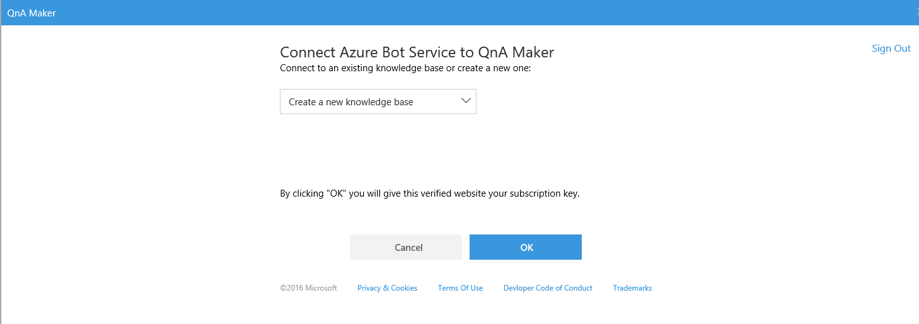

1. Next you will see the status which indicates the Bot is being created. This will take several minutes while this is being completed

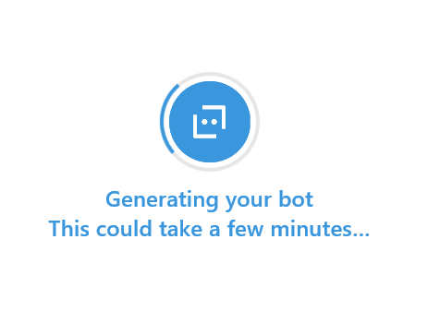

|  |
| --- |
| QnA Maker for the Bot to create questions and answers |

### Use QnA Maker to create the Questions and Answers for your Bot

The data you will use in this lab will be created in the QnA Maker.

1. 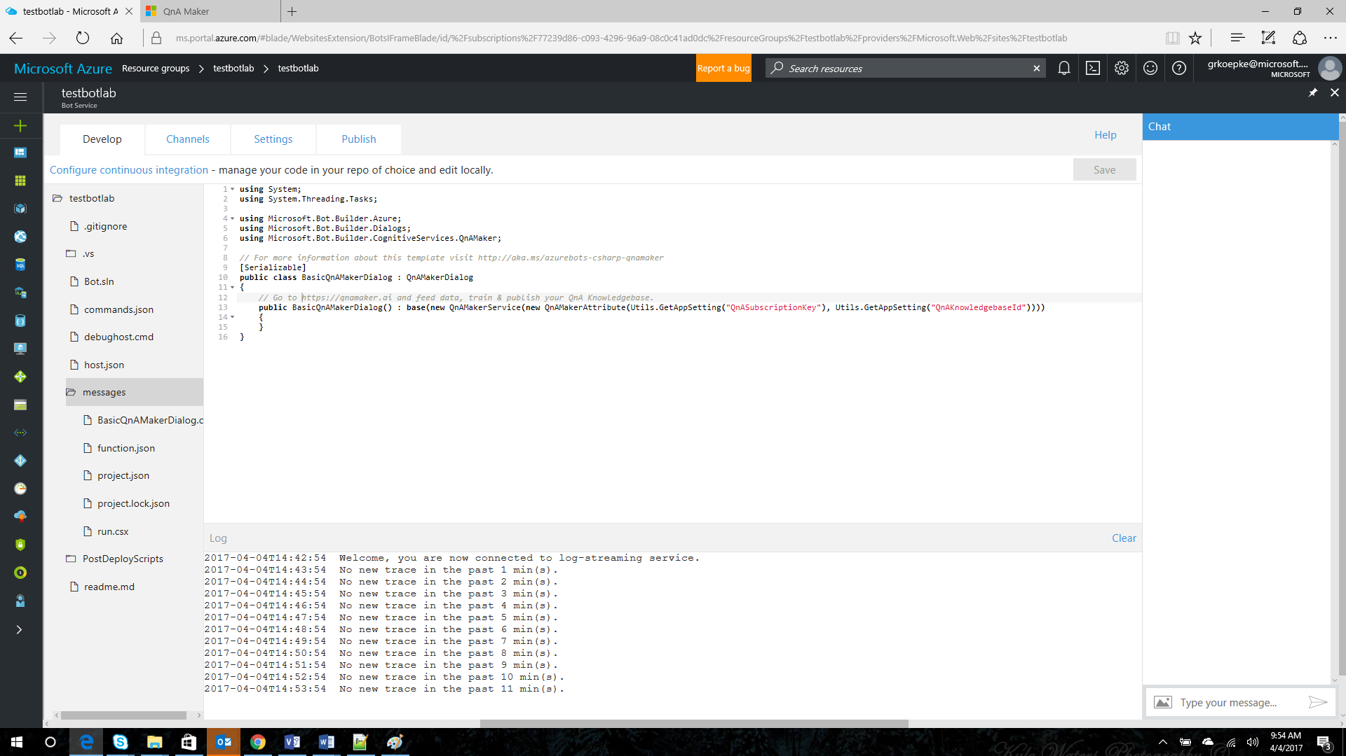In the Bot Service there will be an http link [https://qnamaker.ai](https://qnamaker.ai/) where you will be directed to the QnA Maker. This is also embedded in the code in your BasicQnAMakerDailog.csx code.
2. Click on the <https://qnamaker.ai> to navigate to the QnA Maker. Notice the amount of documentation and the menu items at the top of the screen. Click on the Create New Service link

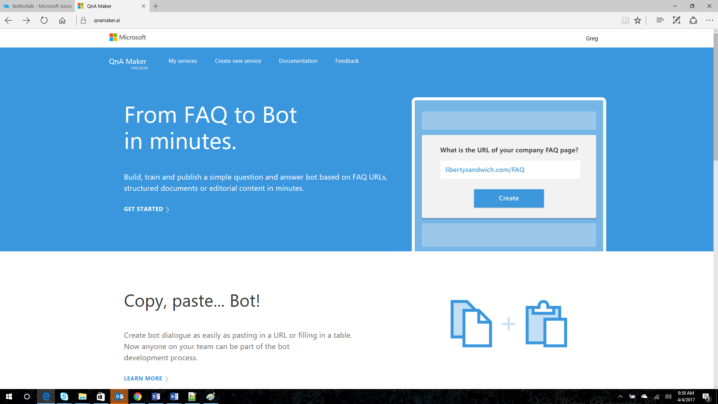

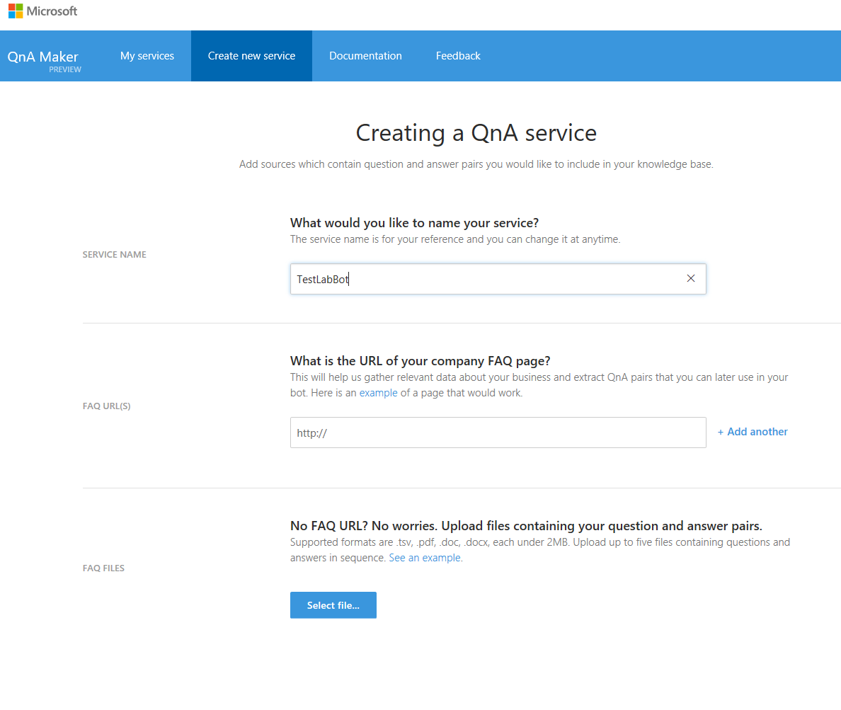

1. 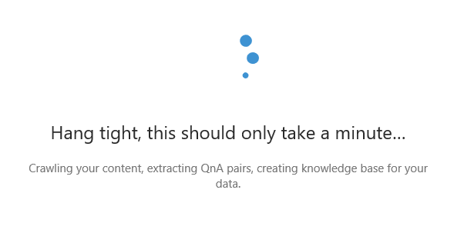Here you will enter a new name for your SERVICE NAME. Then we will select the option to Starting from Scratch option. Click the Create button on the bottom of this screen and if needed scroll down.
2. You will then be brought to the QnA Knowledge Base where you will create your Question and Answers for the Bot.

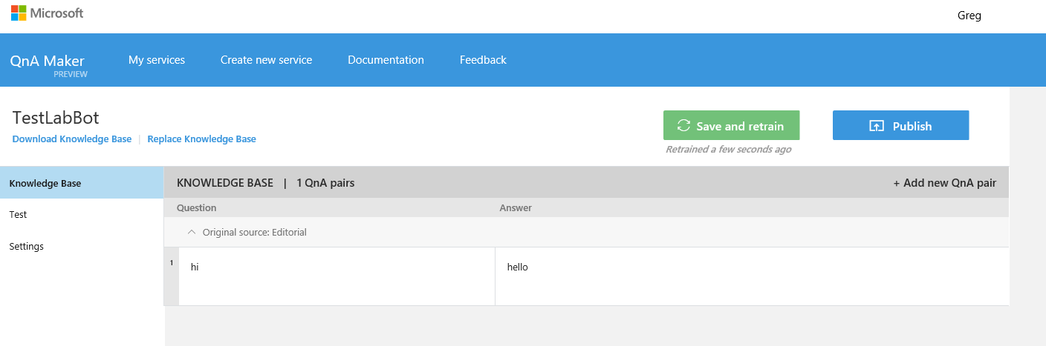

1. Here you will see a default set with a sample QnA. Click on the Add new QnA pair towards the upper left section under the Knowledge Base editor. Enter in your Questions and Answers then click the Save and Train button.

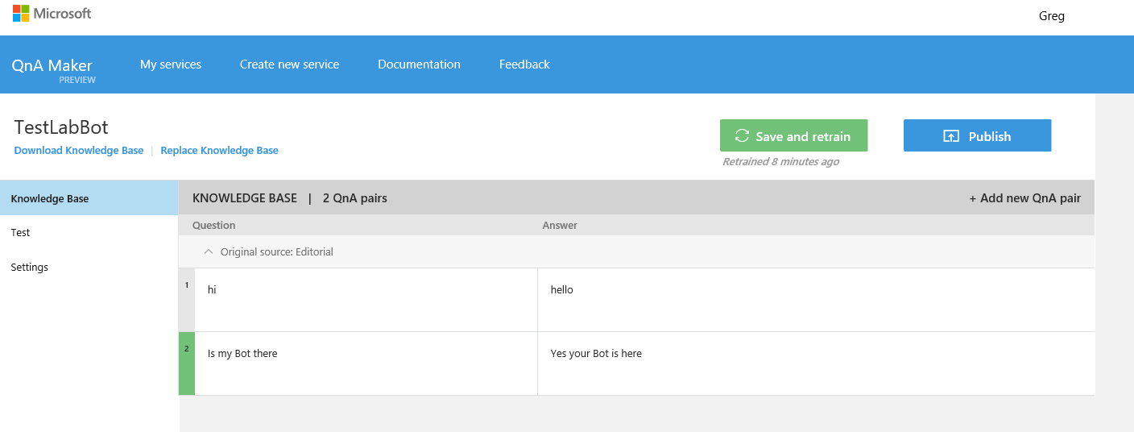

1. Next click Test to look at what you can see with QnA Maker.
2. Next click the Publish button.

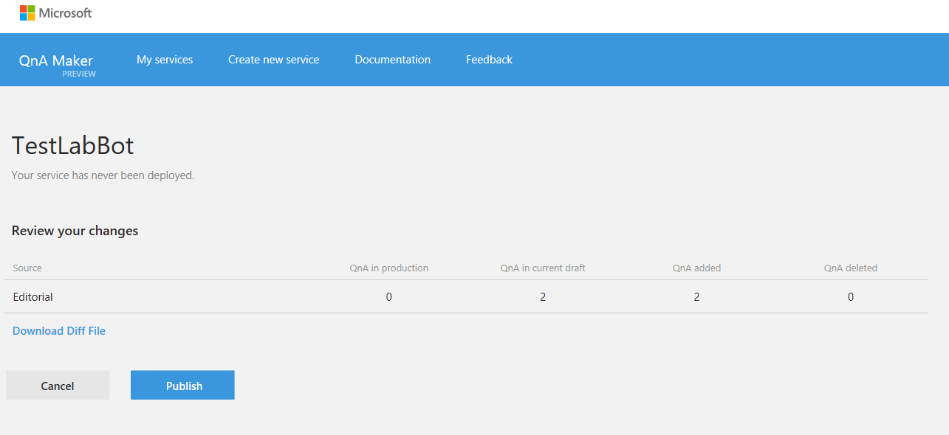

1. After the Publish process is complete you will then be directed to a screen where you will need to copy and paste several values into the Bot Framework inside the Azure Portal.

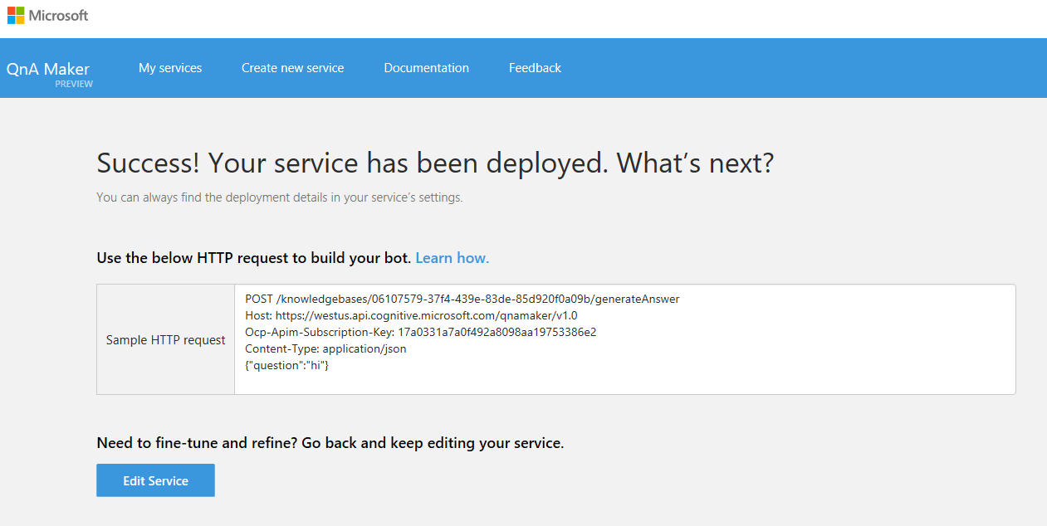

1. Copy the string from the first line as shown below. This is the Application ID and paste into a text editor such as Notepad.

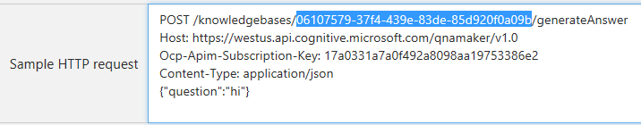

1. Next copy the string on the second line as shown below This is the Subscription ID and paste into a text editor such as Notepad.

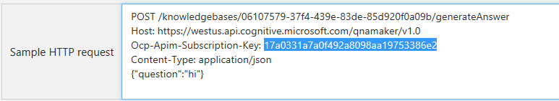

1. Now that you have the Knowledge Base ID and the Subscription Key you will then navigate to the Azure Portal to paste these values into the Bot Framework. Click the Setting Tab and navigate to the right blade where you can click on the Open Application Setttings balde.

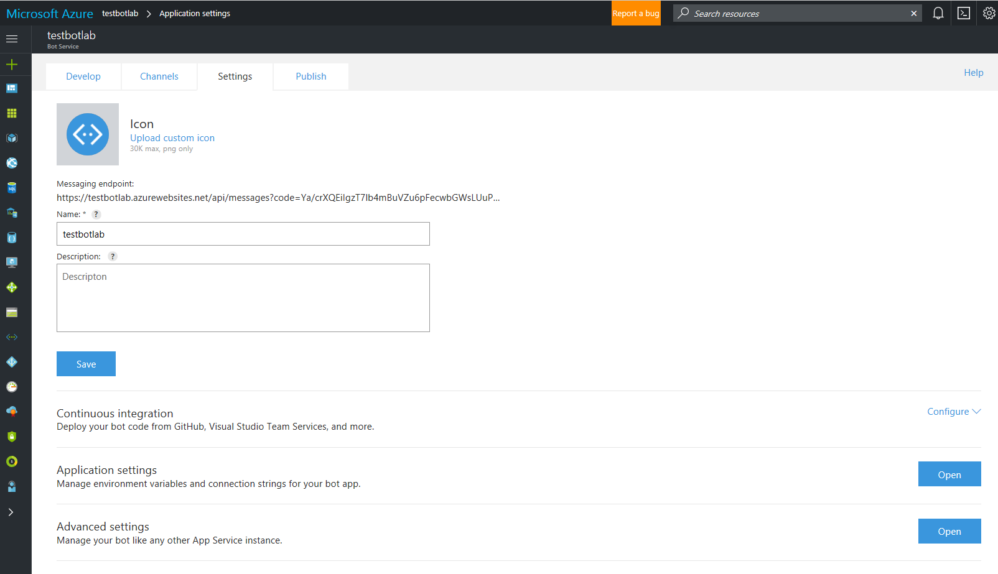

1. Now you will see the Application Setting blade.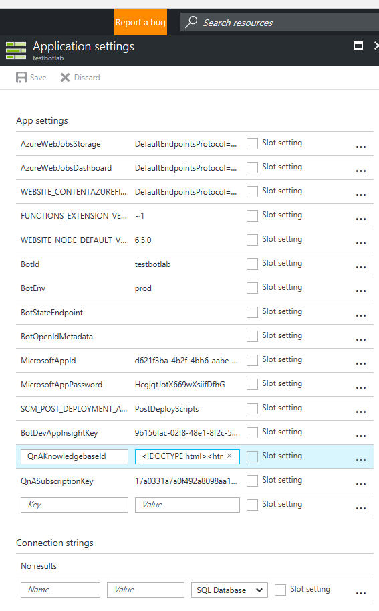
2. 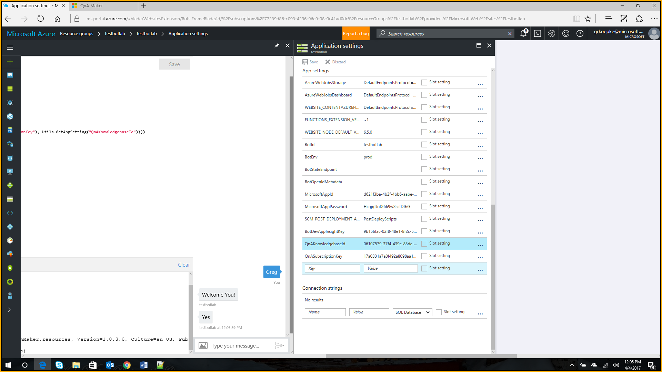Now paste in the KnowledgebaseID and SubscriptionKey and click Save.
3. 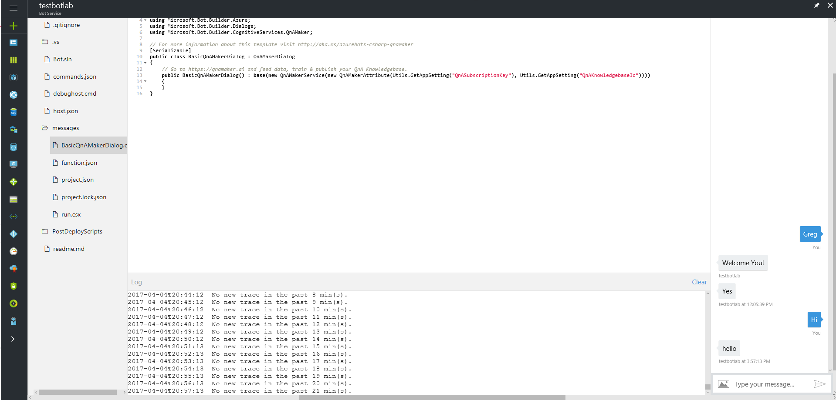Next you can use the Bot by typing in the questions you entered in the QnA Pair!

### 

### Conclusion

This concludes the *Question and Answer Bot using Azure Portal and QnA Maker* lab. In this lab, you created a Bot Service in the Azure Portal and used the QnA Maker to provide a list of questions and answers for the Bot to reference.

fs

|  |
| --- |
| Terms of Use |

© 2015 Microsoft Corporation. All rights reserved.

By using this Hands-on Lab, you agree to the following terms:

The technology/functionality described in this Hands-on Lab is provided by Microsoft Corporation in a “sandbox” testing environment for purposes of obtaining your feedback and to provide you with a learning experience. You may only use the Hands-on Lab to evaluate such technology features and functionality and provide feedback to Microsoft.  You may not use it for any other purpose. You may not modify, copy, distribute, transmit, display, perform, reproduce, publish, license, create derivative works from, transfer, or sell this Hands-on Lab or any portion thereof.

COPYING OR REPRODUCTION OF THE HANDS-ON LAB (OR ANY PORTION OF IT) TO ANY OTHER SERVER OR LOCATION FOR FURTHER REPRODUCTION OR REDISTRIBUTION IS EXPRESSLY PROHIBITED.

THIS HANDS-ON LAB PROVIDES CERTAIN SOFTWARE TECHNOLOGY/PRODUCT FEATURES AND FUNCTIONALITY, INCLUDING POTENTIAL NEW FEATURES AND CONCEPTS, IN A SIMULATED ENVIRONMENT WITHOUT COMPLEX SET-UP OR INSTALLATION FOR THE PURPOSE DESCRIBED ABOVE.  THE TECHNOLOGY/CONCEPTS REPRESENTED IN THIS HANDS-ON LAB MAY NOT REPRESENT FULL FEATURE FUNCTIONALITY AND MAY NOT WORK THE WAY A FINAL VERSION MAY WORK.  WE ALSO MAY NOT RELEASE A FINAL VERSION OF SUCH FEATURES OR CONCEPTS.  YOUR EXPERIENCE WITH USING SUCH FEATURES AND FUNCITONALITY IN A PHYSICAL ENVIRONMENT MAY ALSO BE DIFFERENT.

**FEEDBACK**.  If you give feedback about the technology features, functionality and/or concepts described in this Hands-on Lab to Microsoft, you give to Microsoft, without charge, the right to use, share and commercialize your feedback in any way and for any purpose.  You also give to third parties, without charge, any patent rights needed for their products, technologies and services to use or interface with any specific parts of a Microsoft software or service that includes the feedback.  You will not give feedback that is subject to a license that requires Microsoft to license its software or documentation to third parties because we include your feedback in them.  These rights survive this agreement.

MICROSOFT CORPORATION HEREBY DISCLAIMS ALL WARRANTIES AND CONDITIONS WITH REGARD TO THE HANDS-ON LAB , INCLUDING ALL WARRANTIES AND CONDITIONS OF MERCHANTABILITY, WHETHER EXPRESS, IMPLIED OR STATUTORY, FITNESS FOR A PARTICULAR PURPOSE, TITLE AND NON-INFRINGEMENT.  MICROSOFT DOES NOT MAKE ANY ASSURANCES OR REPRESENTATIONS WITH REGARD TO THE ACCURACY OF THE RESULTS, OUTPUT THAT DERIVES FROM USE OF THE VIRTUAL LAB, OR SUITABILITY OF THE INFORMATION CONTAINED IN THE VIRTUAL LAB FOR ANY PURPOSE.

DISCLAIMER

This lab contains only a portion of the features and enhancements in Microsoft Azure Machine Learning. Some of the features might change in future releases of the product.